**Practical 5**

**(PART – A)**

|  |  |
| --- | --- |
| Roll No. A016 | Name: Varun Khadayate |
| Program : B-Tech(CSBS) | Division: CSBS |
| Batch: B2 | Date of Experiment: 11/8/2020 |
| Date of Submission: 11/8/2020 | Grade : |

***Aim: To be able to design Moore and Mealy machine and should be able to interconvert it.***

**Outcome:** After successfully competing with this practical, students will be able to learn:

* What is the Moore machine? How to design it? How does it operate?
* What is a Mealy machine? Hot to design it? How does it operate?
* Interconversion of these two machines

**A.1 Reading**

Read Exp 8 and 9 of the Lab manual. Page 48 to 58

**A.2 Tasks**

1. Construct a Mealy machine that accepts the language consisting of strings from ∑*, where ∑ = {0, 1}, and ending with double 0’s or double 1’s.
2. Convert the Mealy machine shown in Figure B below to the Moore machine.

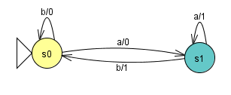

Figure B

1. Construct a Moore machine/transducer for adding two positive binary numbers. Convert it to the equivalent Mealy machine.

**PART B**

(PART B: TO BE COMPLETED BY STUDENTS)

**(Students must submit the soft copy as per the following segments within two hours of the practical. The soft copy must be uploaded on the Portal or emailed to the concerned lab in charge faculties at the end of the practical in case the there is no portal access available)**

**B.1 Output:**

1. Write the procedure to design Moore and Mealy machine and its interconversion.

2. Verify whether the output given by Moore and Mealy machine is the same.

**Task 1**

Q1. Construct a Mealy machine that accepts the language consisting of strings from ∑*, where ∑ = {0, 1}, and ending with double 0’s or double 1’s.

Ans: We assume that the output alphabet is Δ = {1, 0}, indicating whether the input

string is accepted or not. 1- yes/ 0-no.

1. Open JFLAP tool and select Mealy machine.
2. Using State Creator Tool create 3 states.
3. Using the Transition Creator Tool create the transitions along with their outputs.
4. Using Attribute Creator Tool make q0 as initial state. The resultant diagram is the required mealy machine.

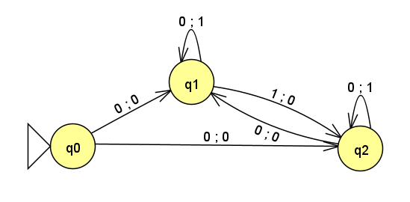

Q2. Convert the Mealy machine shown in Figure B below to the Moore machine.



Ans: From the given Mealy machine construct the State Transition tables:

|  |  |  |  |  |  |  |
| --- | --- | --- | --- | --- | --- | --- |
| **∑**  Q | **a** | **b** |  | **∑**  Q | **a** | **b** |
| S0 | S1 | S0 |  | S0 | 0 | 0 |
| S1 | S1 | S0 |  | S1 | 1 | 1 |

  a) δ: Q x ∑                                                                          b) λ: Q x ∑ -> ∑

 State the new Q’ for Moore machine and using the Mealy to Moore formula find all the   transitions for Moore machine.

Q’ = [Q x Δ] = {[S0,0], [S0,1], [S1,0], [S1,1]}

1. δ’([S0,0], a) = (δ [S0, a], λ[S0,a] )

                   = [S1,0]

δ’([S0,0], b) = (δ[S0,b], λ[S0,b] )

                   = [S0,0]

λ’([S0,0]) = 0

1. δ’([S0,1], a) = (δ [S0, a], λ [S0, a])

                    = [S1,0]

δ’([S0,1], b) = (δ [S0, b], λ [S0, b])

                    = [S0,0]

λ’([S0,1]) = 1

1. δ’([S1,0], a) = (δ [S1, a], λ [S1, a])

                    = [S1,1]

δ’([S1,0], b) = (δ [S1, b], λ [S1, b])

                    = [S0,1]

λ’([S1,0]) = 0

1. δ’([S1,1], a) = (δ [S1, a], λ [S1, a])

                   = [S1,1]

δ’([S1,1], b) = (δ [S1, b], λ [S1, b])

                     = [S0,1]

λ’([S1,1]) = 1

Open JFLAP tool and choose Moore Machine

1. Using State Creator Tool create 4 states. Set their outputs.
2. Using Transition Creator Tool create the transitions according to the calculation done above.
3. Using Attribute Creator Tool change the names of the state and then set [S0,0] as initial state.
4. The resultant diagram is the required Moore machine.

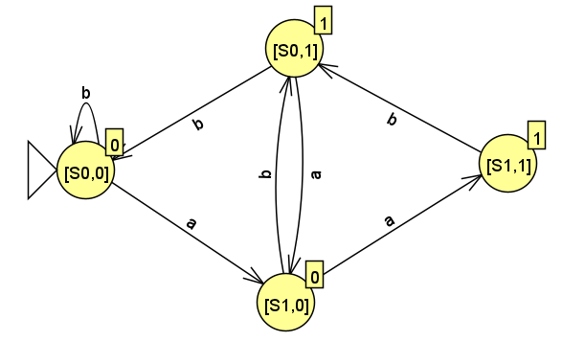

Q3.  Construct a Moore machine/transducer for adding two positive binary numbers. Convert it to the equivalent Mealy machine.

Ans: Open JFLAP tool and select Moore machine.

1. Using State Creator Tool, create 4 states and set their outputs.
2. Using Transition Creator Tool, create all the transitions.
3. Using Attribute Creator Tool set q0/0 as initial states.
4. The resultant diagram is the required Moore Diagram.
5. To convert Moore to Mealy combine both the q0 states and botht the q1 states.
6. Add all the self transitions and transitions between q0 and q1 states.
7. The final diagram will be the required Mealy machine.

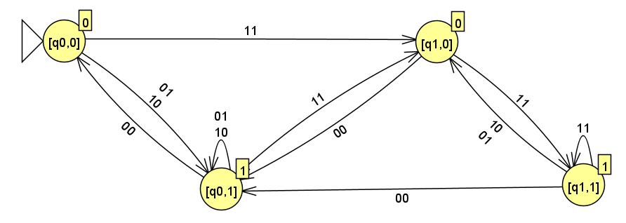

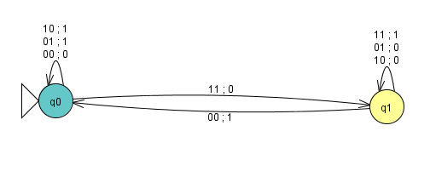

**Task 2**

Q1.

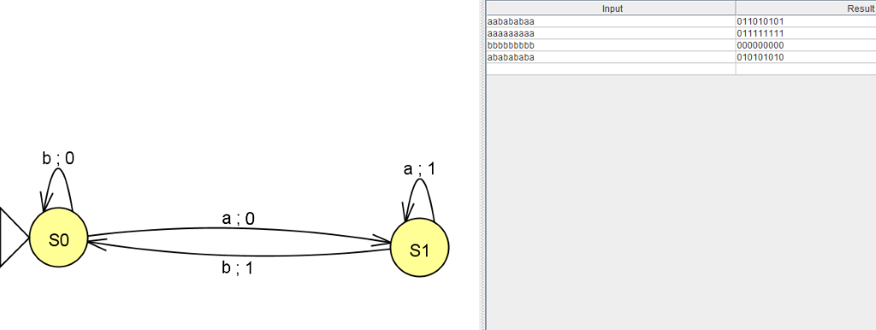

**Mealy Machine**

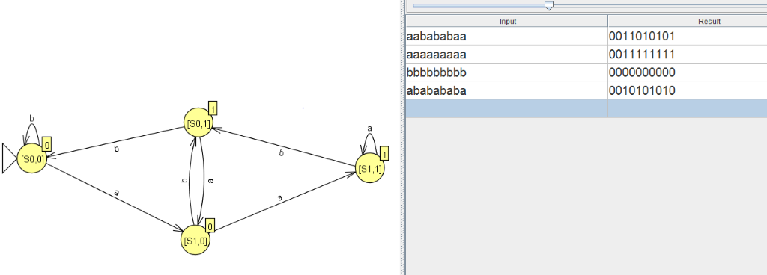 **Moore Machine**

**Q3.**

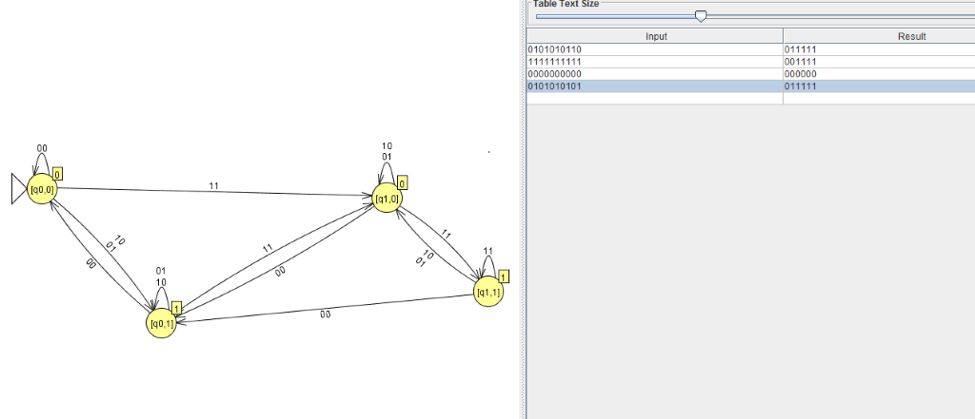

**Moore Machine**

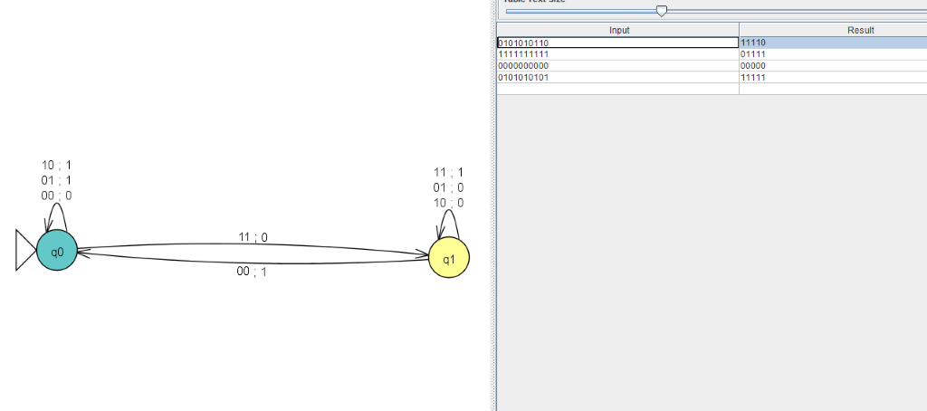

**Mealy Machine**

**B.2 Observations/Learning**

*(Students are supposed to write the logic of constructed DFA and generated regular expression)*

Moore Machine should have the same outputs as that of Mealy machine of the same string.

**B.3 Conclusion:**

*(Students must write the conclusion as per the attainment of individual outcomes and learning/observation)*

The required diagrams were made successfully and converted to Mealy or Moore as asked in the question. The conversion was considered correct only if the inputs of both the machines matched.

***B.4 Curiosity Question***

***Can you generate a general formula to find the total number of states when positions of particular input are fixed from left-hand side? Explain***